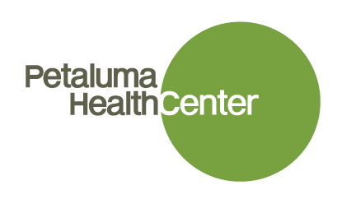
NP/PA Residency Program
Interest Sheet

Title |  |  | First Name |  |  |  | Last |  |  |  |  | MI
Home Address |  |  |  |  | City |  |  |  | State |  | ZIP

Name of NP or PA Program:____________________Date or Expected Date of Completion:____________
If Certified:Name of Organization:_______________Date or Expected Date of Completion:____________
Please list all states in which you are actively licensed to practice:
State: _____ License # _______________Type: RN/NP/PA
State: _____ License # _______________Type :RN/NP/PA
State:______License #________________Type: RN/NP/PA
DEA# if registered:________________________________
Our NP/PA Residency Program starts September 2019. Will this work for you? Yes or No?
Contact Details
Home Phone |  | Cell Phone
Email
Personal Information
Languages Spoken
Languages Written

- What personal, professional, educational and clinical experiences have led you to pursue the profession of a Nurse Practitioner/Physician Assistant as a specialty practice?

- What are your goals for the NP/PA Residency Program, including your aspirations for your short and long term career development?

- How strong are your Spanish skills now (how far can you get in a medical interview without an interpreter?)

- Please describe your desire to train in a Community health center setting as well as your long term commitment to working as a primary care provider who cares for underserved patients.

Thank you for your interest in working with Petaluma Health Center. Once we receive this completed form, we will reach out to you to discuss next steps.

