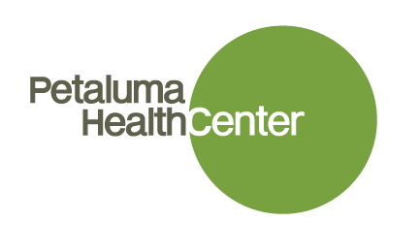
NP/PA Residency Program
Interest Sheet

Title |  |  | First Name |  |  |  | Last |  |  |  |  | MI
Home Address |  |  |  |  | City |  |  |  | State |  | ZIP

Name of NP or PA Program:____________________Date or Expected Date of Completion:____________
If Certified:Name of Organization:_______________Date or Expected Date of Completion:____________
Please list all states in which you are actively licensed to practice:
State: _____ License # _______________Type: RN/NP/PA
State: _____ License # _______________Type :RN/NP/PA
State:______License #________________Type: RN/NP/PA
DEA# if registered:________________________________
Our NP/PA Residency Program starts March or September. Will this work for you? Yes or No?
Contact Details
Home Phone |  | Cell Phone
Email
Personal Information
Languages Spoken
Languages Written

- What personal, professional, educational and clinical experiences have led you to pursue the profession of a Nurse Practitioner/Physician Assistant?

- What are your goals for the NP/PA Residency Program, including your aspirations for your short and long term career development?

- How strong are your Spanish skills now (how far can you get in a medical interview without an interpreter?)

- Please describe your desire to train in a community health center setting as well as your long-term commitment to working as a primary care provider who cares for underserved patients.

Thank you for your interest in working with Petaluma Health Center and being part of our NP/PA Residency Program. Once we reviewed this completed form, we will reach out to you to discuss next steps.

